1)MCQS-

i) Which algorithm is used in finding all pairs shortest distance?

Answer- a) Dynamic Programming is correct answer.

(Floyd-Warshall algorithm)

ii) 0/1 knapsack is based on _____ method?

Answer- b) Branch & Bound(<https://www.youtube.com/watch?v=yV1d-b_NeK8&t=135s>)

c)Dynamic Programming (<https://www.youtube.com/watch?v=nLmhmB6NzcM>)

2 answers possible as knapsack 0/1 can be solved by both but write c Dynamic Programming as it is more efficient.

iii)A ___ is a round trip path along n edges of G that visits every vertex once and returns to its starting position.

Answer-

d)Hamiltonian Cycle

(used in Travelling salesman problem)

iv)The upper bound on the time complexity of the nondeterministic sorting algorithm is?

Answer-   
O(n)

Non deterministic algorithmss always reduce time complexity.

(<https://www.youtube.com/watch?v=ZNe1ziMExGg>)

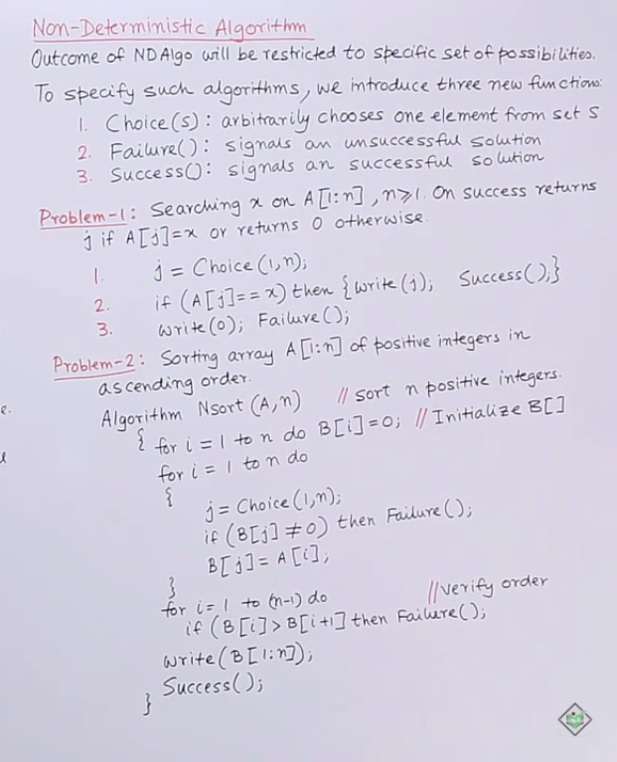

v)Choose the correct answer-

I.Theory of NP-Completeness provides a method for providing polynomial time for NP Problems.

II. All NP Problems are NP-Hard.

Answer- a)I is false and II is true

Explanation- <https://youtu.be/e2cF8a5aAhE>, <https://www.geeksforgeeks.org/np-completeness-set-1/>

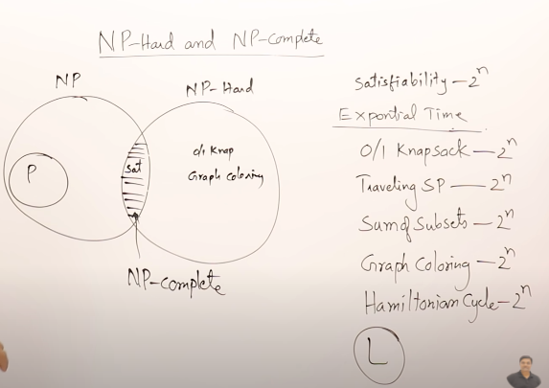

Similar mcq(for practise)

**----**

**The following are the statements regarding the NP problems. Chose the right option from the following options:**

**I. All NP-complete problems are not NP-hard.**

**II. Some NP-hard problems are not known to be NP-complete.**

Answer-Only II is true.

Grp B Qs 2

Page 1 of creating MST using Kruskal

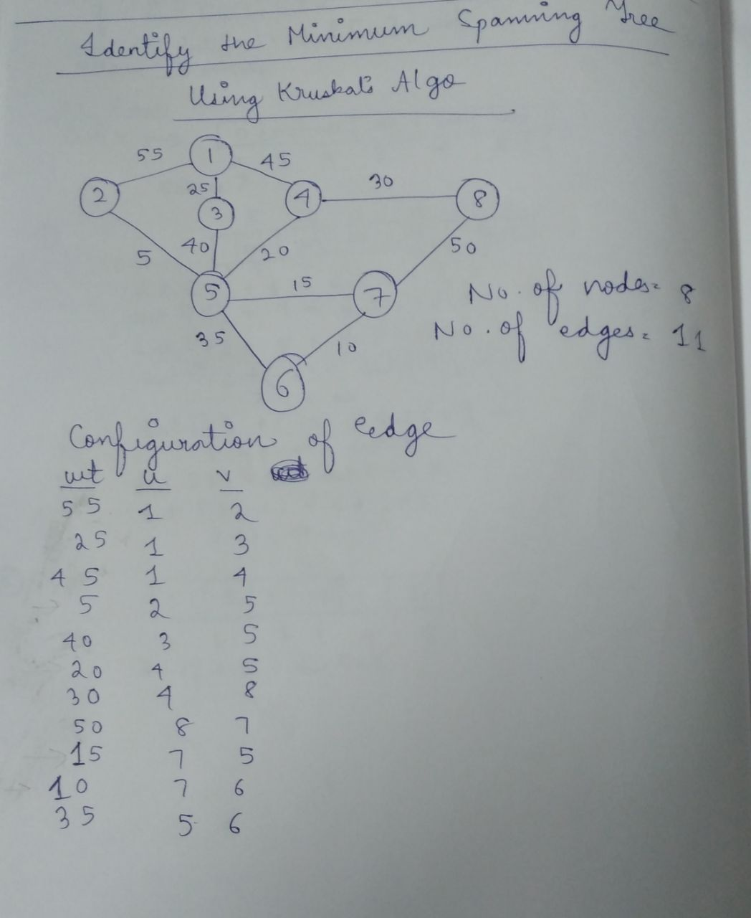

Page 2 of creating MST using Kruskal

